**SYSTEM PATH**

A file path **specifies the location of a file in a computer's file system structure**. They can be used to locate files and web resources, like Media files, such as images , music, and videos.

## PATHS AND PATH SEPARATORS

In general, a path is a string of characters which specifies a unique location in a directory or page hierarchy. For file systems, each level in the hierarchy is a directory. Different sections of the path are separated by a path separator, such as a forward slash (/). These different sections represent the separate directories or pages in the hierarchy, as shown below:

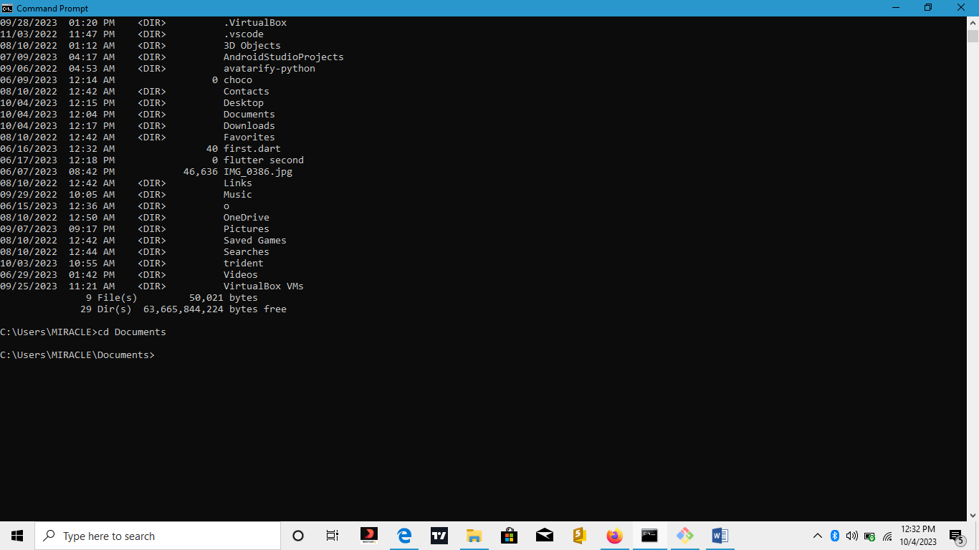

In this file path, the **Documents** file is inside the **MIRACLE** directory. The **MIRACLE** directory is a subdirectory of the **Users** directory, which is a subdirectory of the **C:** directory. File paths are one example of a path. Paths are also an important component of URLs.

**URLS AND FILE PATHS**

URLs specify the location where data and websites are hosted on the web. URLs and file paths both function similarly and provide the location a computer must go to find a particular resource. However, a major difference is that URLs locate resources which are hosted on the Internet, and file paths locate resources which are stored locally or on a local network.